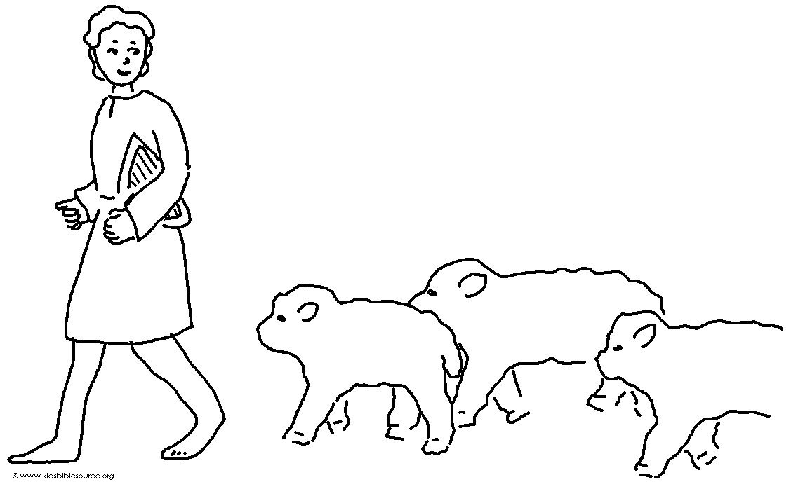
Listen to my instruction and be wise. Don't ignore it. Proverbs 8:33_{NLT}

